In the past, we stored information in files, books which were hard to maintain and very importable. Worse still, when the information were needed to help us to make decisions, it would took substantial time and resource to look up and analyze.

Now, things are different. We live in a world of data now, everything can be stored as bits in disks, documents, photos, videos and so on. We have developed many sophisticated database to reliably store and look up the data. However, when we talk about efficiently and highly customized search and analysis, they are insufficient. Then some amazing applications come to rescue. Elasticsearch is one of them.

Elasticsearch is an open source, distributed and RESTful search engine. It provides you the power to fully make use of your data, whether it is used to support high-performance search feature for applications with giant data storage (PB level) or involved in some cutting edge areas like machine learning.

Its distributed feature makes it to meet the high-performance requirement. It is nearly real-time, which means the data can be searched almost instantly after being stored. What’s more Elasticsearch provides all kinds of APIs (RESTful, Java, Python…) for outer applications to communicate with this powerful search engine.

Elasticsearch is an open source project started by Shay Banon. The predecessor of this project is called Compass, an abstract layer for Java programmers to conveniently and efficiently use the powerful search engine-Apache Lucene. His original purpose of developing this program is used to help his wife to search for recipes. The first public version of Elasticsearch released in 2010, and it soon became one of the mostly active project in Github. Then a company (Elastic) is established to offer commercial service revolving Elasticsearch and some other projects (The Elastic Stack)

So things get a little complicated, there are three licenses in this project – Apache License 2.0, Apache License 2.0 compatible license, and the Elastic License. The Elastic license is used for advanced functions. In a word, it’s not fully free. You have to pay for some features such as access control and security. And Elastic provides integrated cloud service.

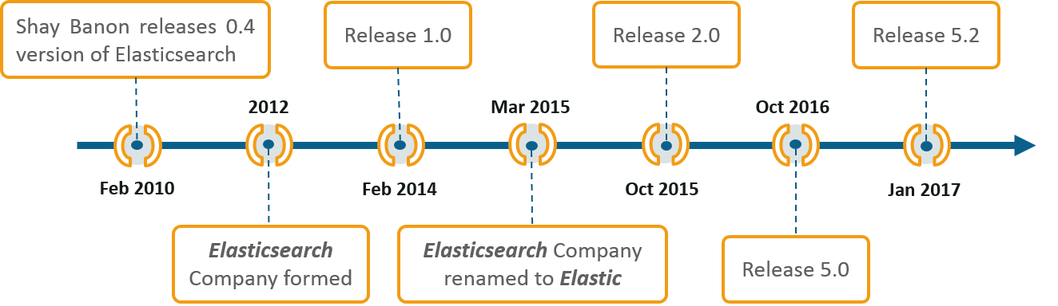

(Figure 1: history of Elasticsearch and Elastic)